
History
Founder Holly Baca is a Licensed, Certified Occupational Therapy Assistant for children ages 2-18, who have a variety of diagnoses. Focusing on sensory integration, fine motor skill development, executive function training, and life skills education, Holly has seen children thrive in their development when they are physically challenged. Exposing them to the outdoors and engaging them in new experiences that stimulate all their senses allows them to blossom.

In the Fall of 2021, Holly was determined to give her clients something more…something that would give them agency and social connection, while building on the basics like executive function, social skills, strength, coordination, and problem solving. Inspired by Annapolis’s access to the water and nearby trails, as well as a desire to share our resources with kids who might not otherwise seek out these opportunities, Holly came up with the idea for Boundless Edventures.

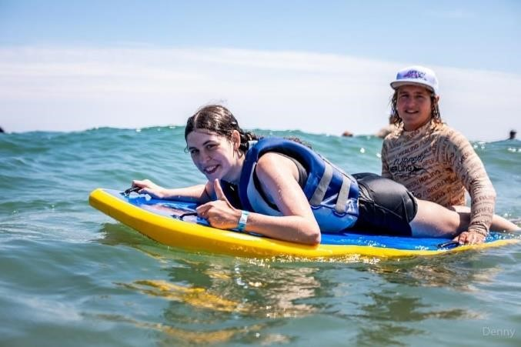
Since then, the program has provided one to three adventures per week for groups of 12 participants, ages 12-20 all year long. Some of these adventures include hiking, fishing, paddle boarding, sailing, boating, swimming, and kayaking.

Mission: Using adventure therapy to help teens overcome social, emotional, physical, and intellectual barriers through outdoor, adventure driven experiences that foster personal growth, social connection and life skills.

Problem
Nationally, our adolescents and young adults are facing a variety of mental health and developmental challenges. According to Autism Speaks, 1 in 36 kids is diagnosed with Autism. The National Institutes of Health estimate one in eight children is diagnosed with an anxiety disorder, with a prevalence between the ages 13 and 18 years of 25 percent. The CDC estimates nearly 10% of children aged 3 to 17 are diagnosed with ADHD, and one-third will retain that diagnosis into adulthood. According to the Maryland State Department of Education, nearly 55,000 students in grades 6-12 are classified as disabled, which includes physical, mental, behavioral, and intellectual limitations.

Additionally, and especially after they age out of the school system, these young adults find themselves isolated, which contributes to increases in depression and other mental and behavioral health concerns. While the Maryland Department of Disabilities offers resources for education, housing, independent living, and financial support, there are few, if any programs focused around social opportunity or physical activities.

Children and young adults with physical, mental, and intellectual challenges are often perceived as either unwilling or incapable of exploring the outdoors or participating in outdoor adventure activities. These populations often have difficulty making friends, don't like team sports, spend all their free time on computers, don't like to go outside, and have trouble stepping out of their comfort zone.

Response
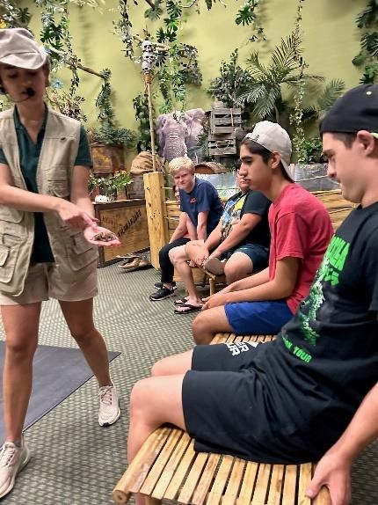
We are strong believers in the ability of our youth to succeed. Our programming and activities are designed to help our youth reach their goals and fulfill their highest potential. We are proud of all our adventurers, and love watching them grow into bright-minded and confident individuals. Every season brings new and exciting opportunities to navigate the Chesapeake Bay and its tributaries, explore the beautiful forests and trails, and experience the historic landmarks of Maryland.

A study published in 2021 by the National Institutes of Health notes that “[h]ealth benefits associated with exposure to nature include improved physical health, but the majority of the findings center on improved mental well-being.” Additionally, a 2016 study by the Journal of Adolescence argues that outdoor programs “can increase self-efficacy, mindfulness and subjective well-being. Furthermore, programs may reduce feelings of time pressure and mental stress amongst participants.”

Program Details
Our programs serve participants ages 12-20 with challenges such as autism spectrum disorder, anxiety and depression, Attention Deficit Disorder, Cerebral Palsy, and Down Syndrome. We are the only organization of our kind serving this population. We provide 1:3 volunteer to adventurer assistance. This helps with more challenging excursions and for those who are unstable or lack coordination. We tether our kayaks and paddle boards together and give hands-on guidance and training for fishing and archery.

Families invest $75-$200/month depending on how many adventures are scheduled. Adventures are planned according to seasons. We depend on surrounding communities, partner organizations and local business for resources, guided excursions, and water access, including Soulwater Sports for boating and tubing, Lucky and Blessed Fishing for catching fish, Terrapin Adventures for Ropes course and caving, and CapSUP for paddle boarding. Each adventure is designed to expose our group to something that challenges their comfort zone and physical abilities. This promotes teamwork and fosters social engagement.

Environmental conservation education is also a component of our programming. Our kids participate in oyster restoration at five different locations on the Magothy River. Additional conservation programs will be offered through our relationship with the Chesapeake Bay Foundation.

Our all-volunteer staff is a mix of professional educators, pediatric therapists, and outdoor enthusiasts. All participants are physically abled.

Some of the adventures we’re planning for 2026 include: sailing, hiking, paddleboarding, team-building ropes course, camping, rock wall climbing, kayaking, river tubing, and much more.

Impact
In just four years, we have grown to a roster of 100 families, with 12-15 participants each month and a growing wait list.

Data tracking of self-reported improvements in physical, mental, emotional, and behavioral health through pre- and post-program surveys completed by participants and/or their parents and caregivers give us insight into the efficacy of our programs and how to maintain the best parts of our programs while integrating new offerings or special requests.

Participant Feedback
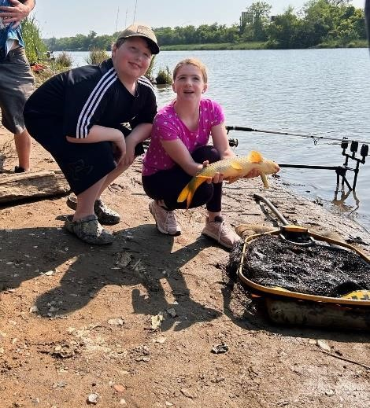
“Payton has tried new adventures that she would have never tried with me. Her confidence has increased tremendously, and she can fish, kayak, paddleboard and rock climb with no fear. Boundless Edventures has been a blessing for Payton to create relationships with others her age and to feel included in outdoor activities.”

“Boundless Edventures has provided a hard-to-find social space where my son is accepted and eagerly looks forward to participating in activities. I am so thankful this group exists, that it has such steadfast volunteers, and that we are a part of it!”

"I filled my lonely bubble with all the friends."

“My son has made a whole new group of friends, he's participated in activities he may have never tried, while working on social skills
and independence. He's having fun! Every week he looks forward to a new adventure. This group has accepted him for who he is, given him confidence, given him much needed breaks from his anxiety and most importantly he is never sitting alone.”

“On the way home from every Edventure, my son talks like never before!”

“As a family, we are so thankful for Boundless Edventures and the investment Holly, Stacy, Paul, and the other volunteers have poured into our daughter. As a teenager with ASD and ADHD, Boundless is THE place outside our home that she feels safe to be her full self. The authentic relationships she has built, the incredible opportunities she’s experienced, and the sense of belonging she feels as a part of this group have been game changers for her…our daughter always comes away feeling seen and valued. As parents, watching her grow in relationships and confidence as she gets to have so many awesome experiences is such a gift. We are so thankful and cannot recommend Boundless Edventures enough!”

Goals
In 2026, Boundless Edventures plans to increase program staff and offerings to accommodate the growing waitlist. We prioritize improving quality of life for our participants in as many areas of their subjective well-being as possible. We plan to provide specialized adventures such as the Boundless SUP Club, and the Boundless family hiking series, to provide opportunity for those who prefer more fast-paced adventures to do so with their like-minded peers.

We are introducing the Boundless Edventures Candle Shoppe; an Executive Function and workforce training workshop to help our youth gain more independent life skills needed to transition out of high school into the workforce or college. Activities in this workshop include development of strategies and tools for organization and time management; breakdown of tasks for efficiency and completion; safe and secure use of bank and money apps such as Zelle, Venmo, and PayPal, along with hands on experience of making candles and selling them to the public at local craft fairs.

Focus on raising funds for a transport van that would allow us to expand our adventure area and offer different experiences for our adventurers, such as kayaking on the Potomac in DC during the Cherry Blossom Festival, snow tubing at Wisp, white water rafting in Harpers Ferry, camping near Luray Caverns and kayaking Blackwater Refuge on the Eastern Shore.

Budget
Through fundraising activities, grant applications, sponsorships, and program fees, we aim to raise $155,000 in 2026 to meet all of our programmatic and staffing goals. Boundless Edventures has been generously supported by our participating families, as well as corporate sponsors such as The Buckley Fund, The Freemasons of Annapolis, Madore Law, Long Fence, The Wine Club, Guest Worship, Fidelity Charitable Donor-Advised Fund and AltaVista Strategic Partners.

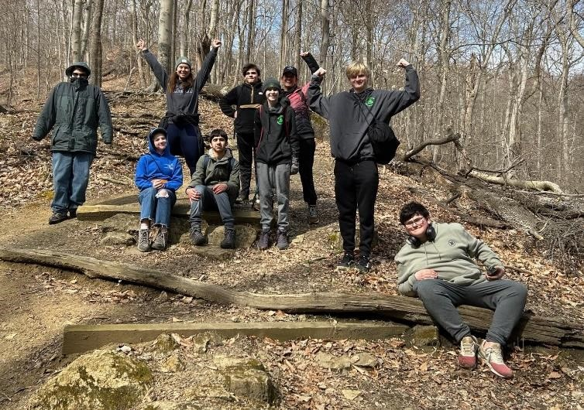

Your support is vital to the growth and success of this program and we thank you!

Maryland State Board of Education. (2023, February 28). Deep Dive: Students with Disabilities - Marylandpublicschools.org. Maryland State Board of Education. https://marylandpublicschools.org/stateboard/Documents/2023/0228/DeepDiveStudentsWithDisabilitiesPart2.pdf
https://mdod.maryland.gov/Pages/Home.aspx
Jackson SB, Stevenson KT, Larson LR, Peterson MN, Seekamp E. Outdoor Activity Participation Improves Adolescents' Mental Health and Well-Being during the COVID-19 Pandemic. Int J Environ Res Public Health. 2021 Mar 3;18(5):2506. doi: 10.3390/ijerph18052506. PMID: 33802521; PMCID: PMC7967628.
Michael Mutz, Johannes Müller. Mental health benefits of outdoor adventures: Results from two pilot studies Journal of Adolescence. Volume 49 2016. Pages 105-114. https://doi.org/10.1016/j.adolescence.2016.03.009.

